GARAGE MANAGEMENT SYSTEM

SRI KRISHNA ADITHYA COLLGE OF ARTS AND SCIENCE

TEAM ID :  NM2025TMID22168

TEAM MEMBERS:

KANISHKA S

KAVIYARASI K

JESVINTH S

JOEL J

TEAM LEADER : KANISHKA S

Email: 23bsit127kanishkas@skacas.ac.in

Team Member1 :KAVIYARASI K

Email: 23bsit131kaviyarasik@skacas.ac.in

Team Member2 : JESVINTH S

Email: 23bsit125jesvinths@skacas.ac.in

Team Member3 : JOEL J

Email: 23bsit126joelj@skacas.ac.in

1.INTRODUCTION

1.1 Project Overview

The Garage Management System is a valuable tool for automotive repair facilities, helping them deliver top-notch service, increase operational efficiency, and build lasting customer relationships. With its user-friendly interface and powerful features, GMS empowers garages to thrive in a competitive market while ensuring a seamless and satisfying experience for both customers and staff.

1.2 Purpose

The purpose of a Garage Management System is to streamline and automate the daily operations of a vehicle service center, including customer and vehicle management, service booking, inventory tracking, and billing. It helps improve efficiency, reduce manual errors, and maintain accurate service and payment records.

DEVELOPMENT PHASE

Creating Developer account

By using this

URL: <https://developer.salesforce.com/signup>

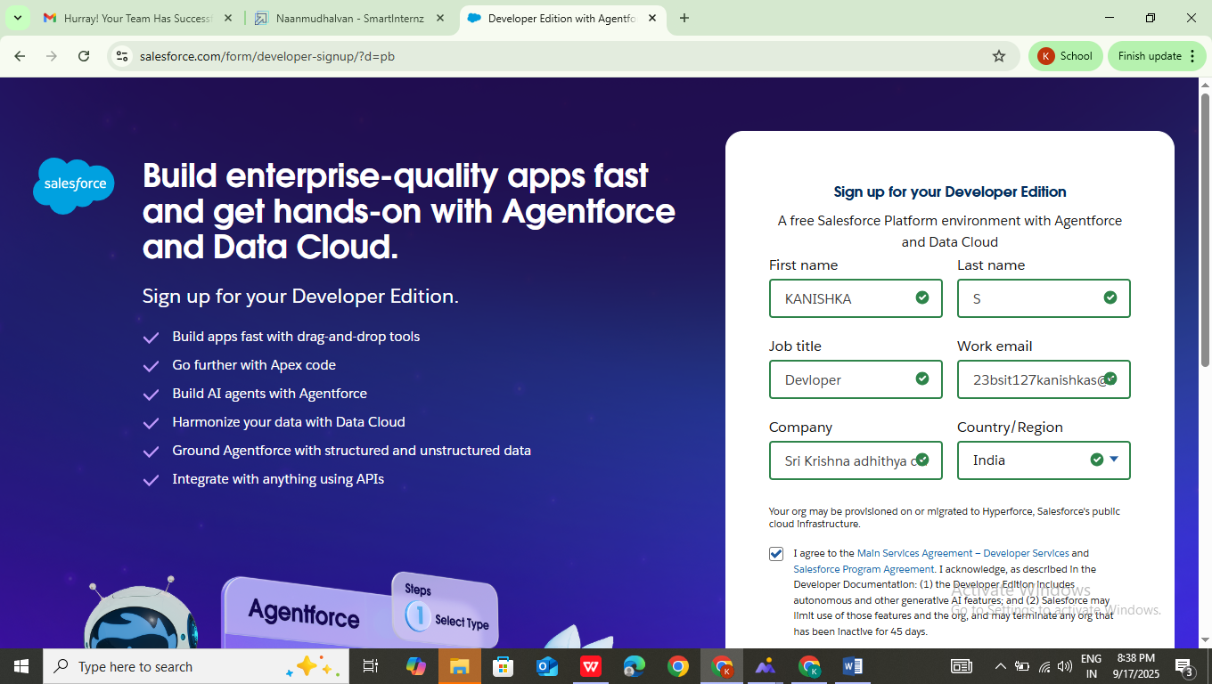

Account Activation

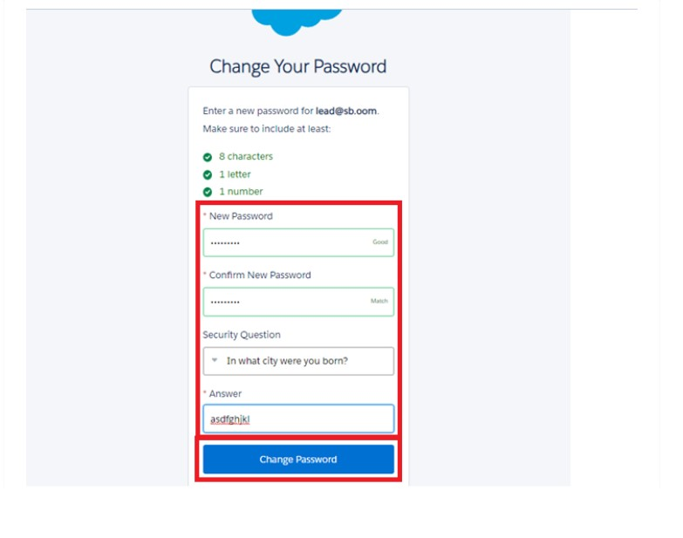

This will redirect to your salesforce setup page.

Create Objects: Customer Details, Appointments, Service Record, Billing Details and Feedback Object.

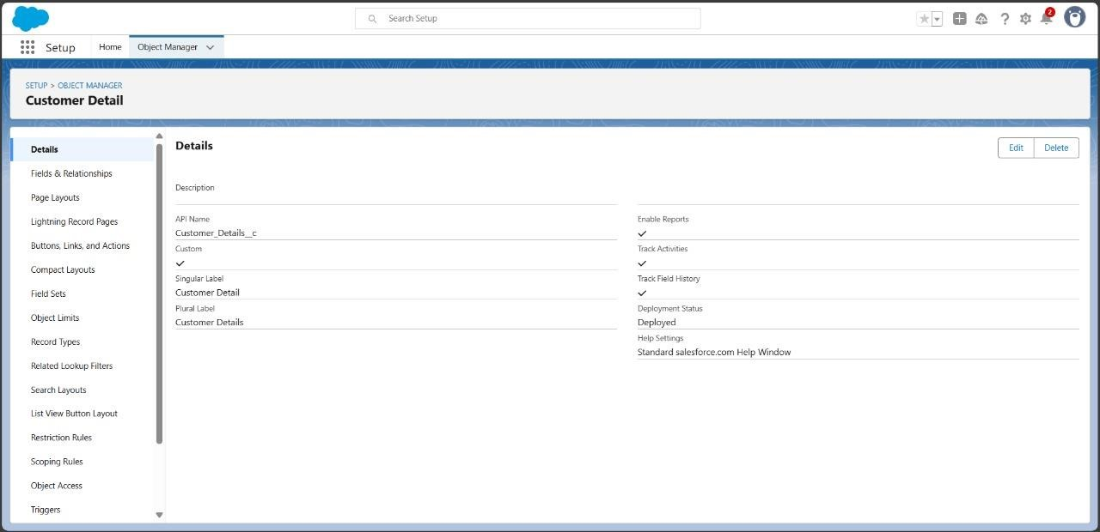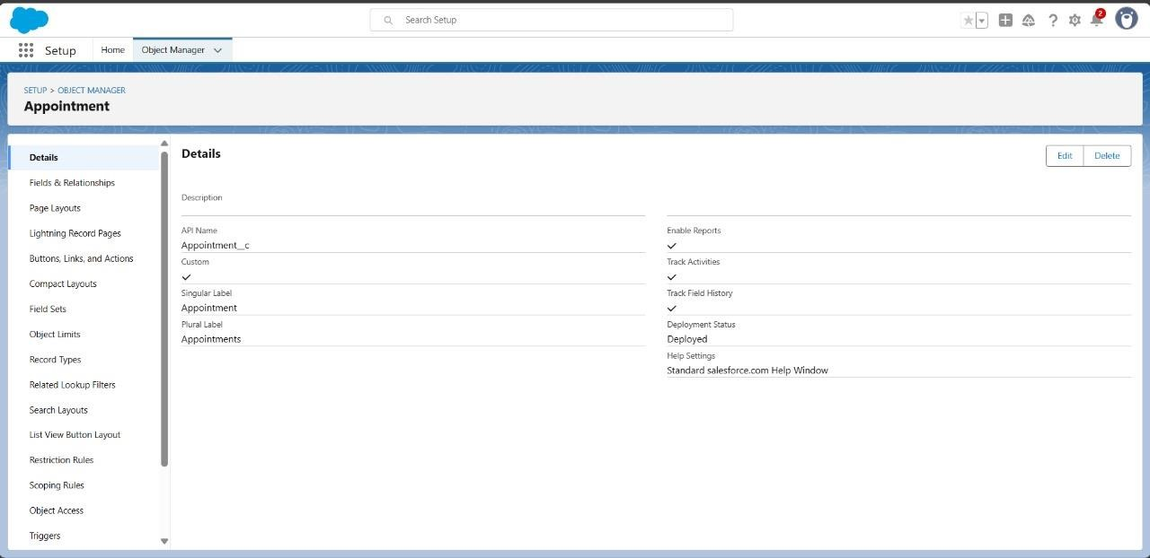

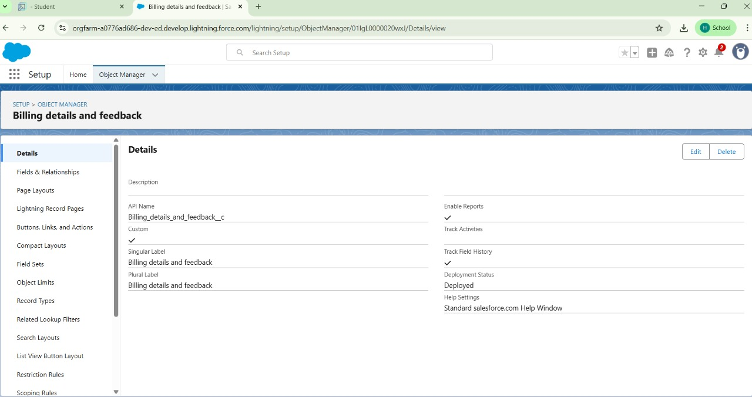

Create Objects: Customer Details, Appointments, Service Record, Billing Details and Feedback Object

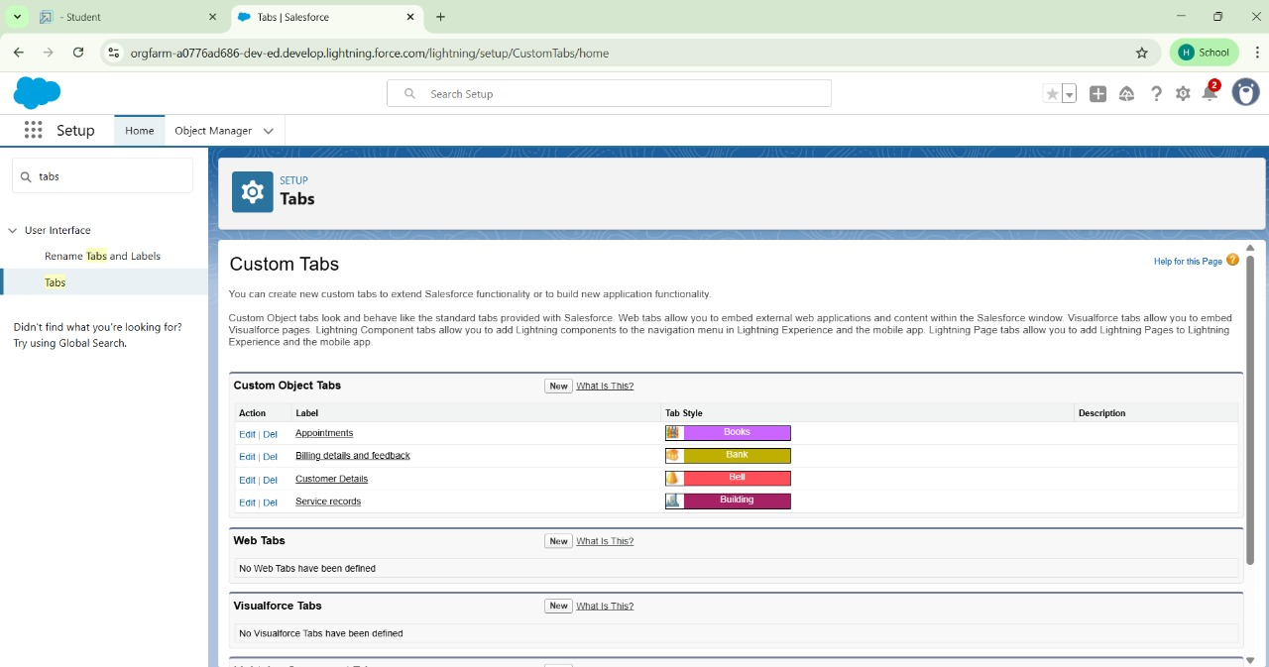

Lightning App is been developed with the name” Garage Management Application “.

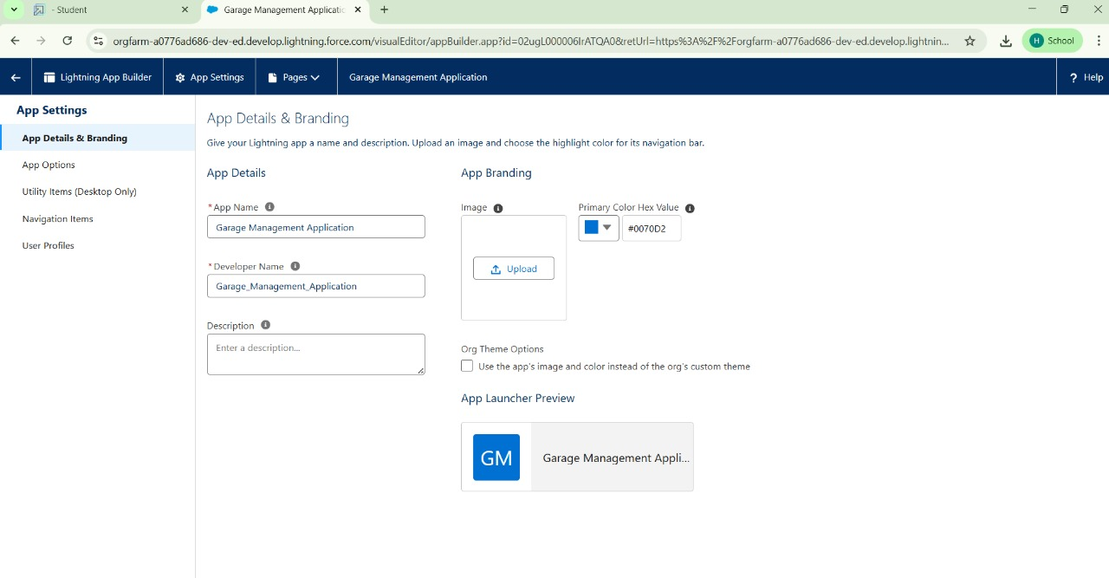

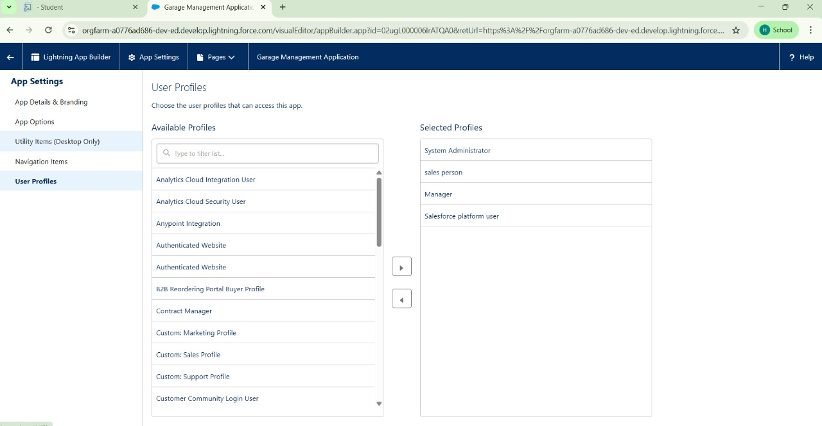

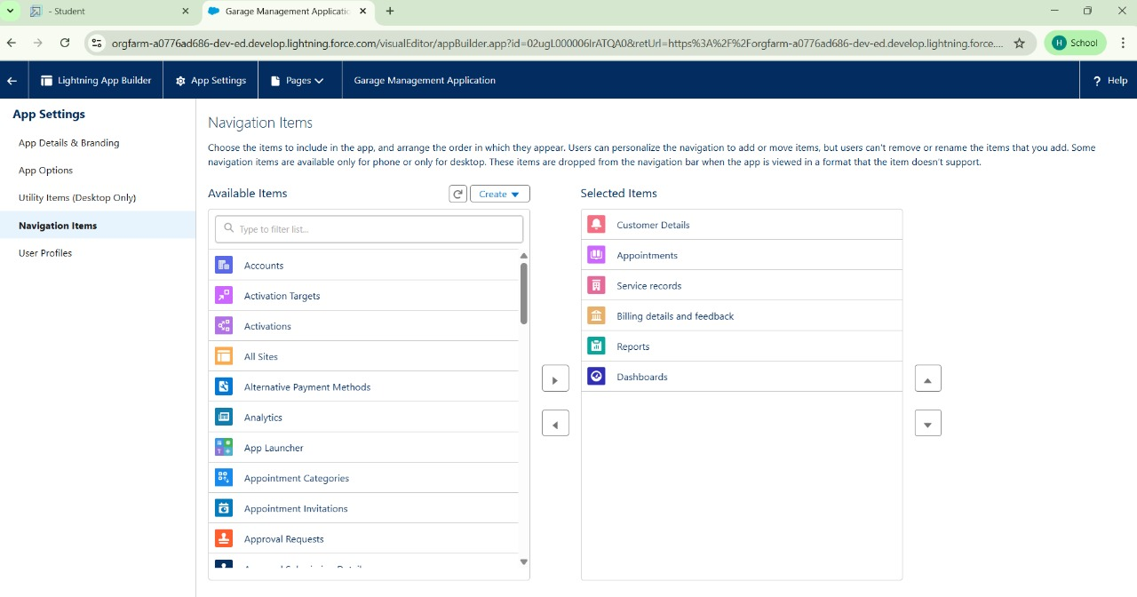

Configured fields and relationships

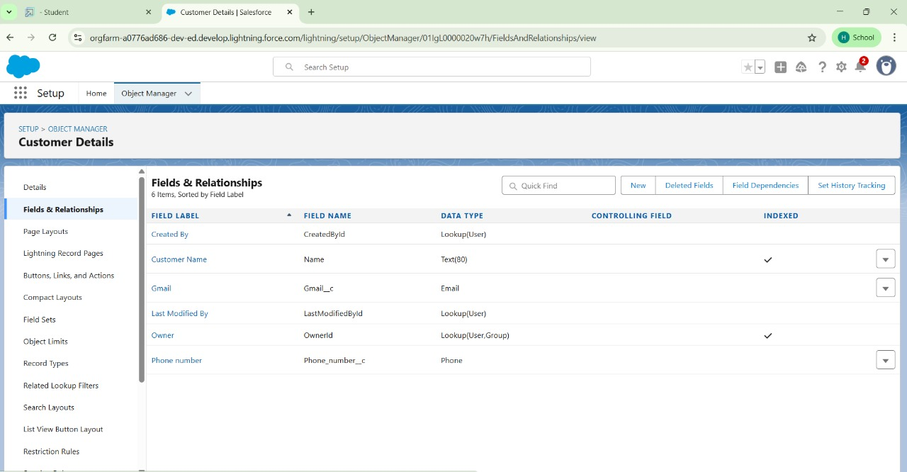

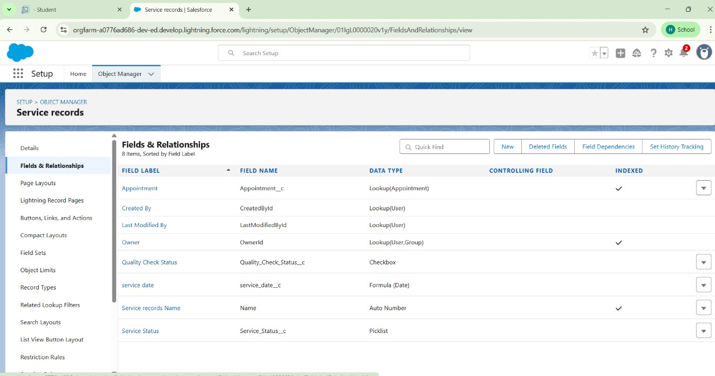

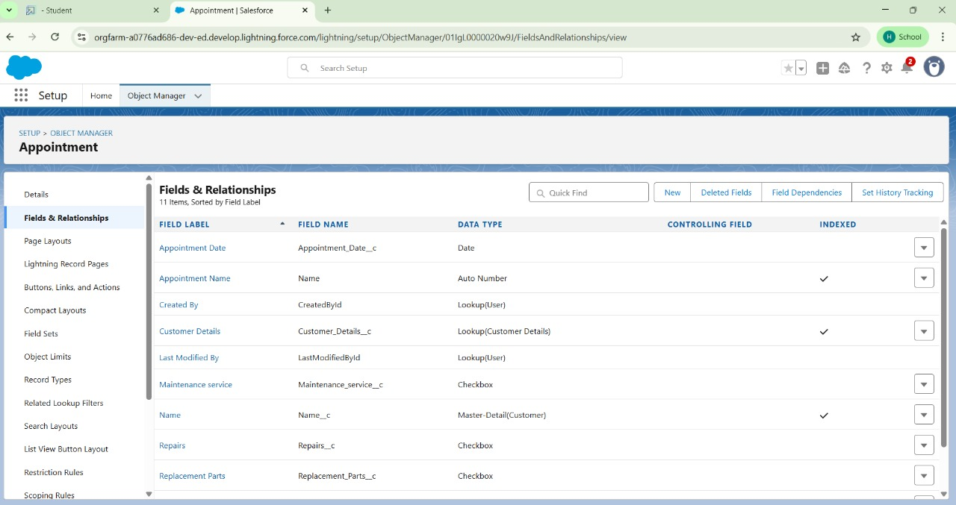

Create a Validation Rule

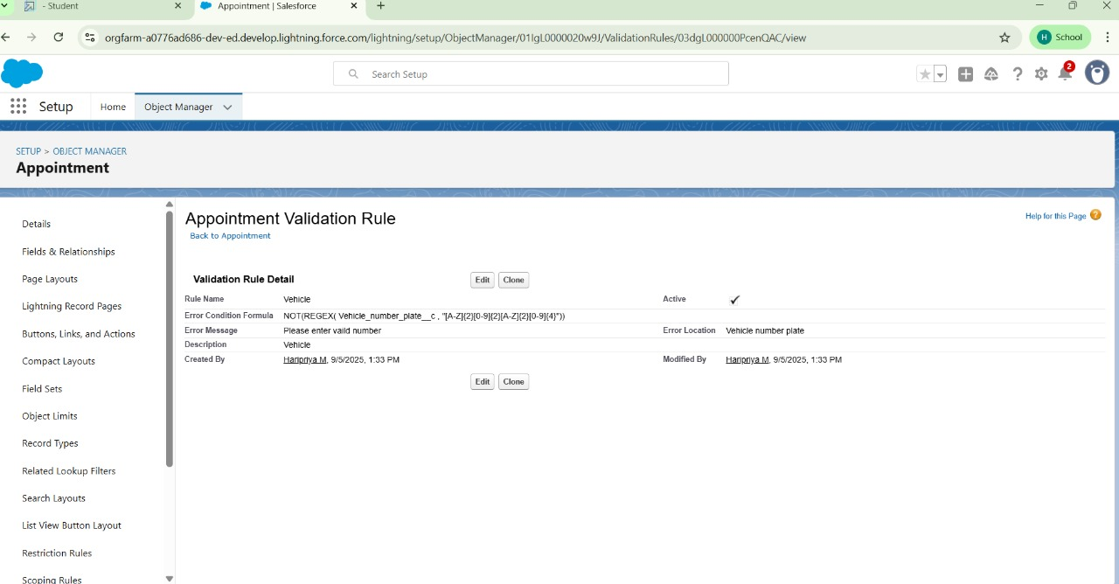

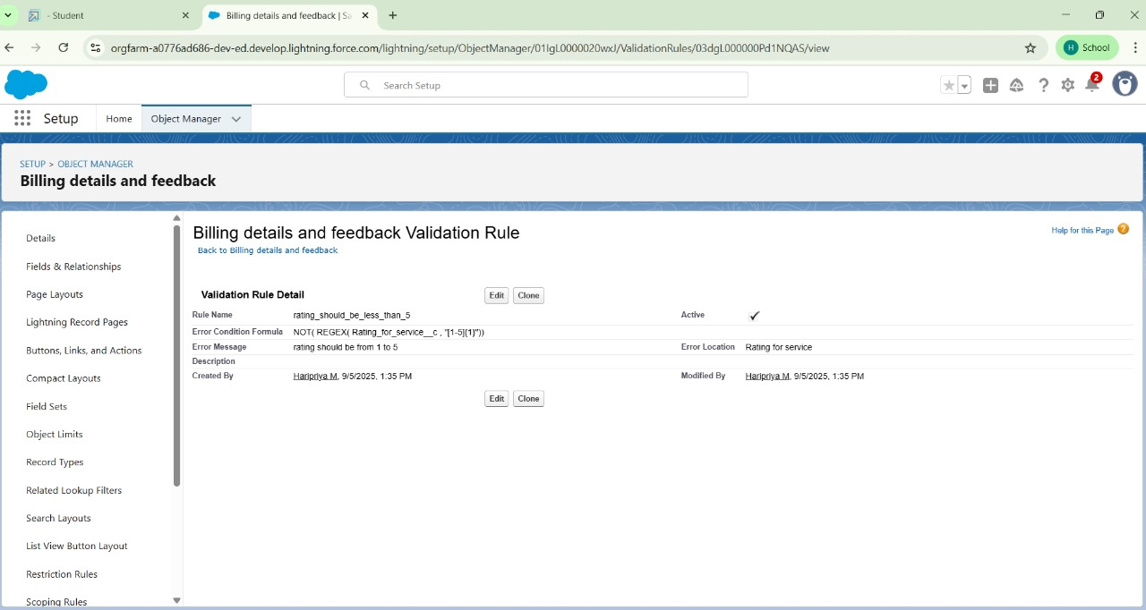

Create a Duplicate Rule

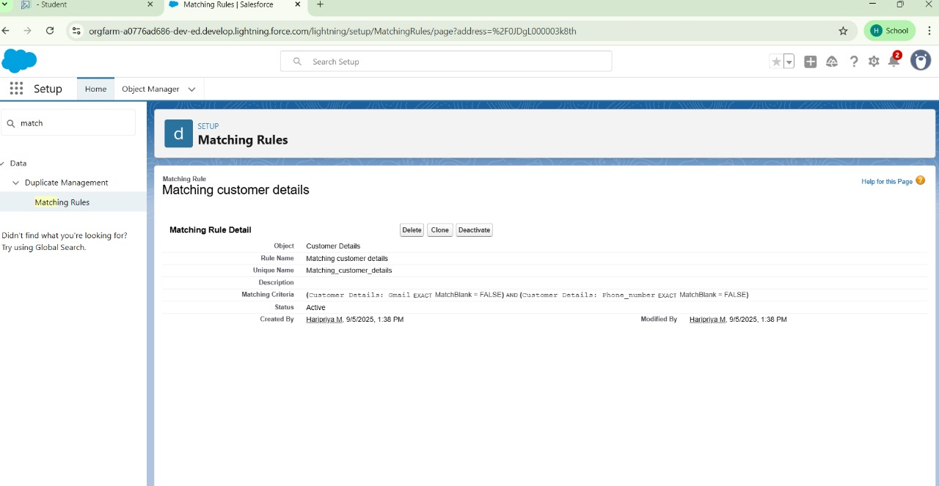

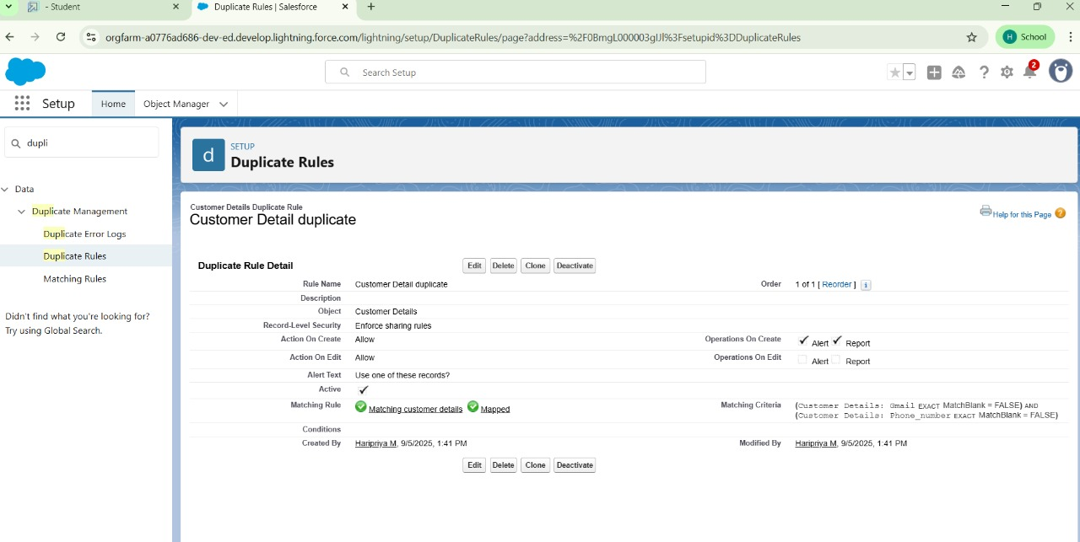

Creating a Profile

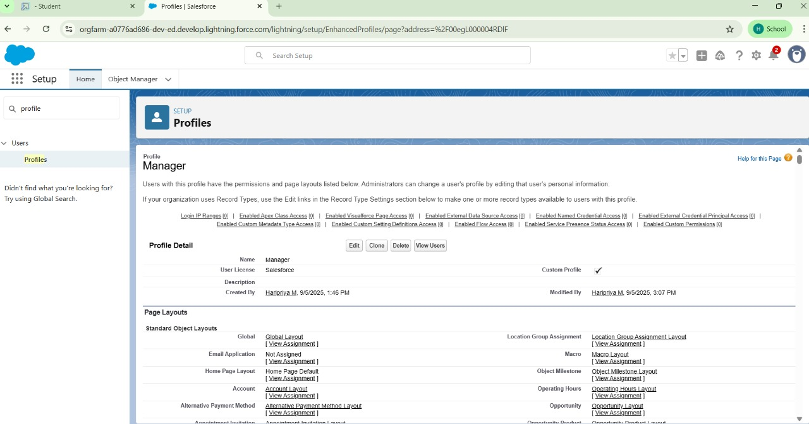

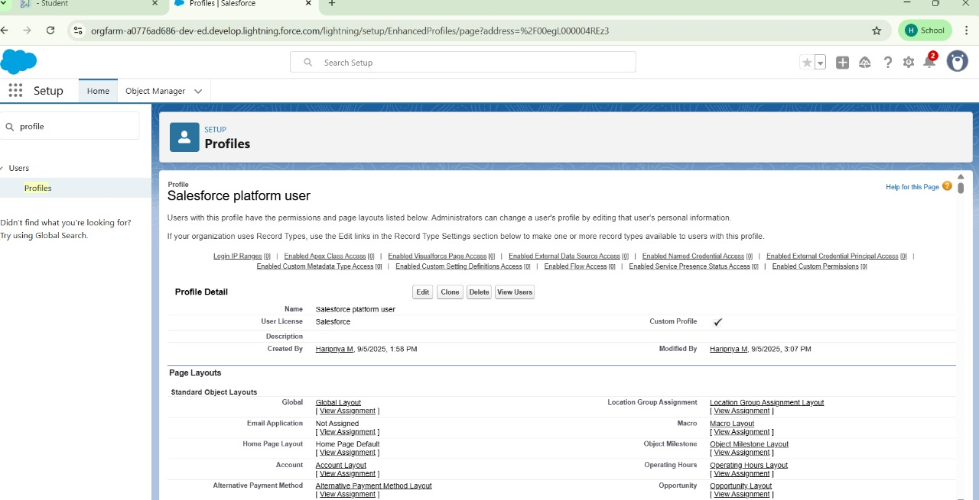

Creating Role and Role Hierarchy ”Manager” and “Sales Person”

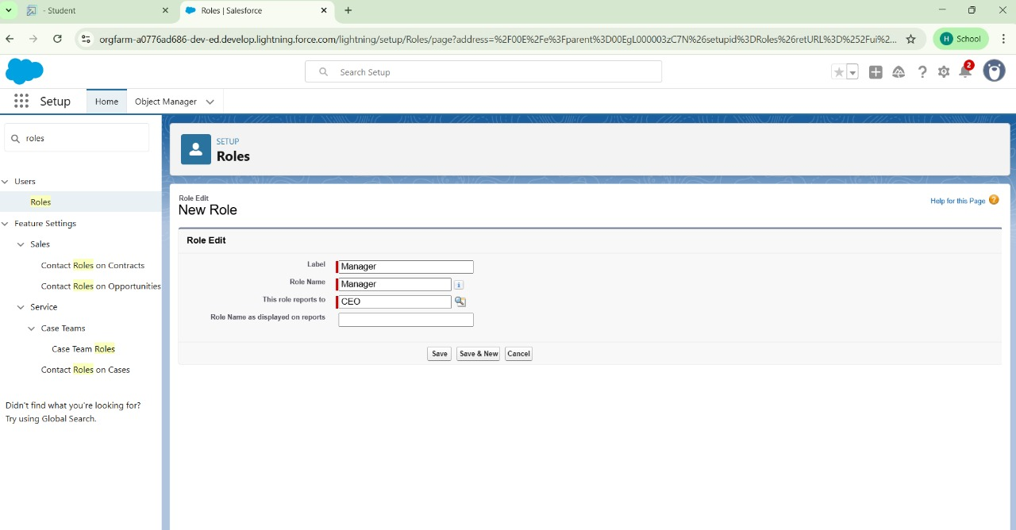

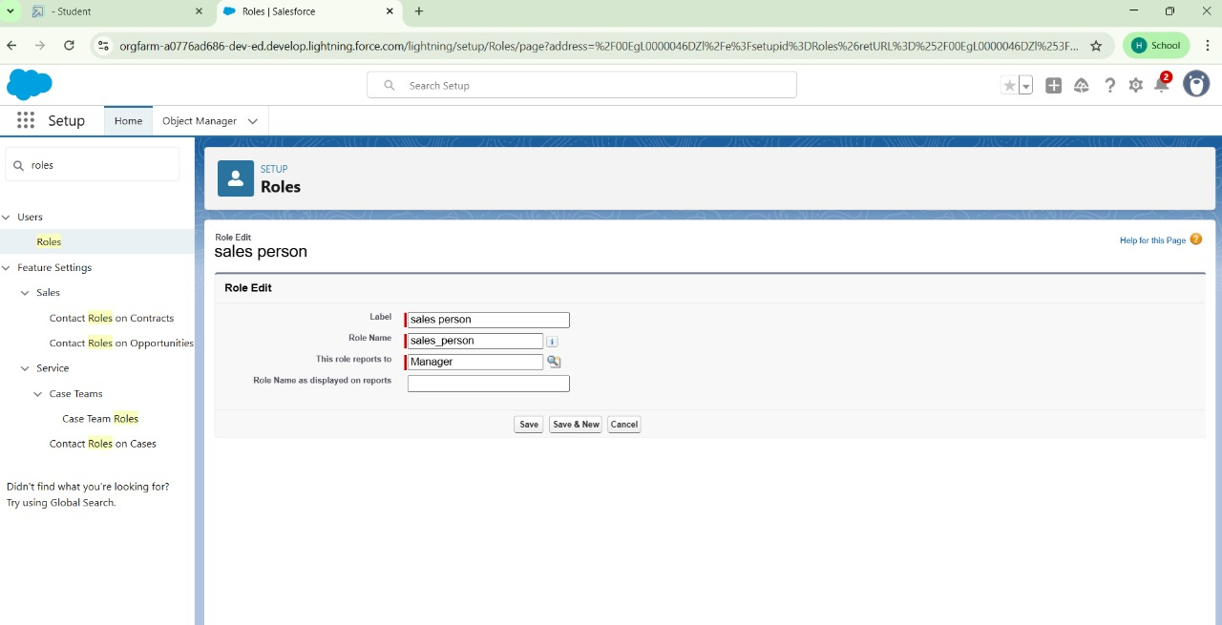

Creating users as Niklaus Mikaelson and other users

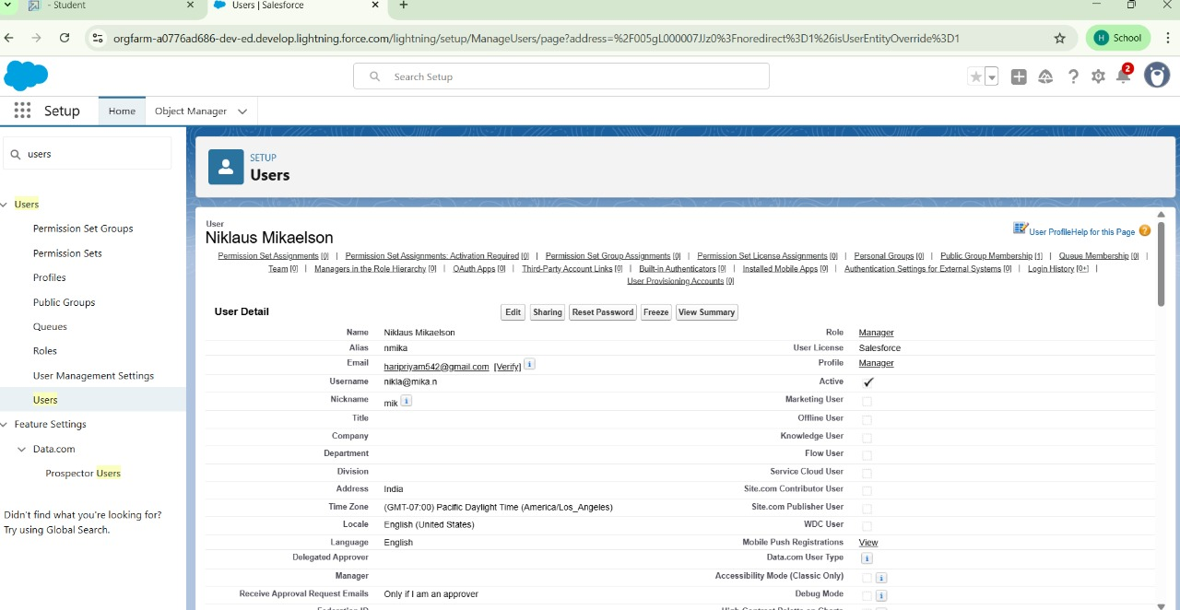

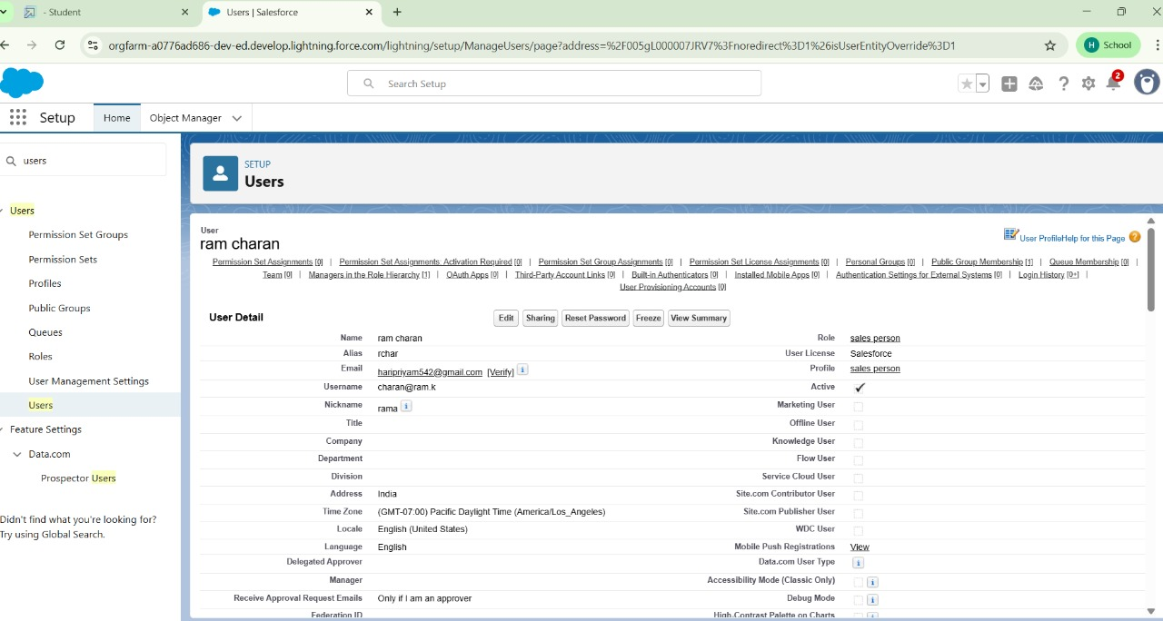

Creating New Public Group “Sales Team”

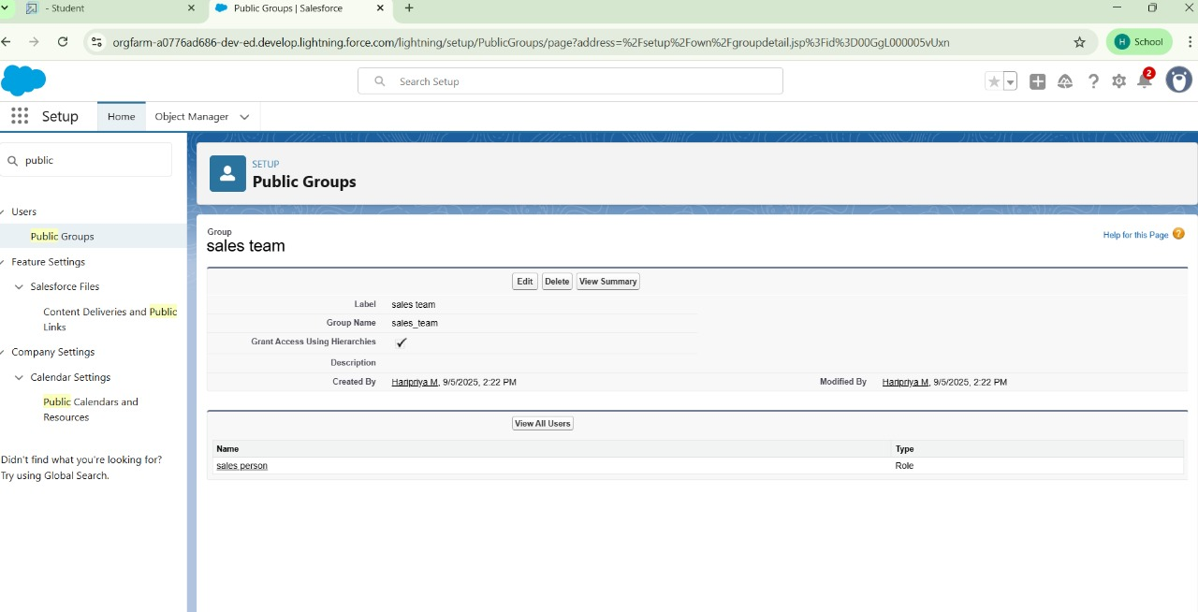

Creating Sharing Settings “Sharing setting”

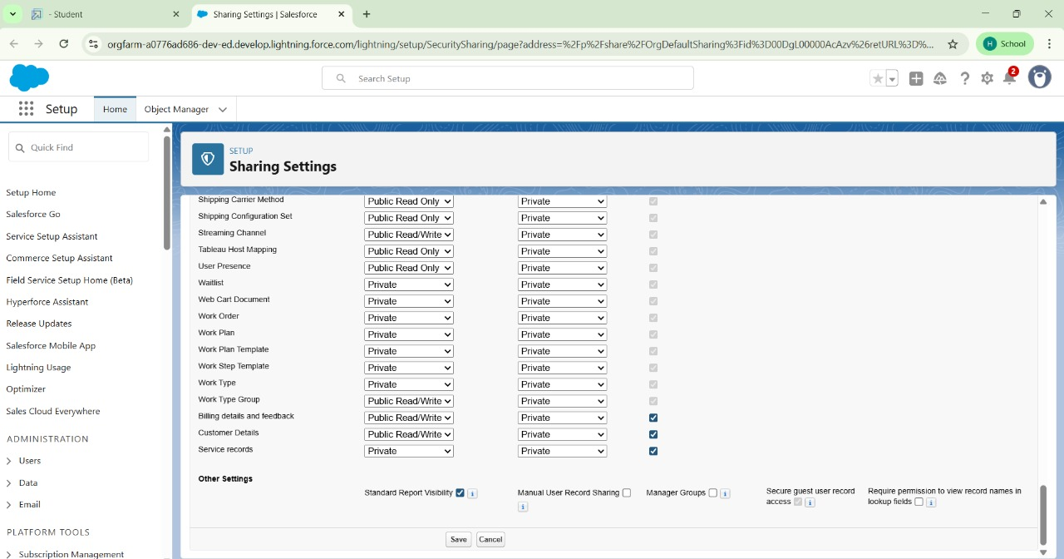

Creating Flows

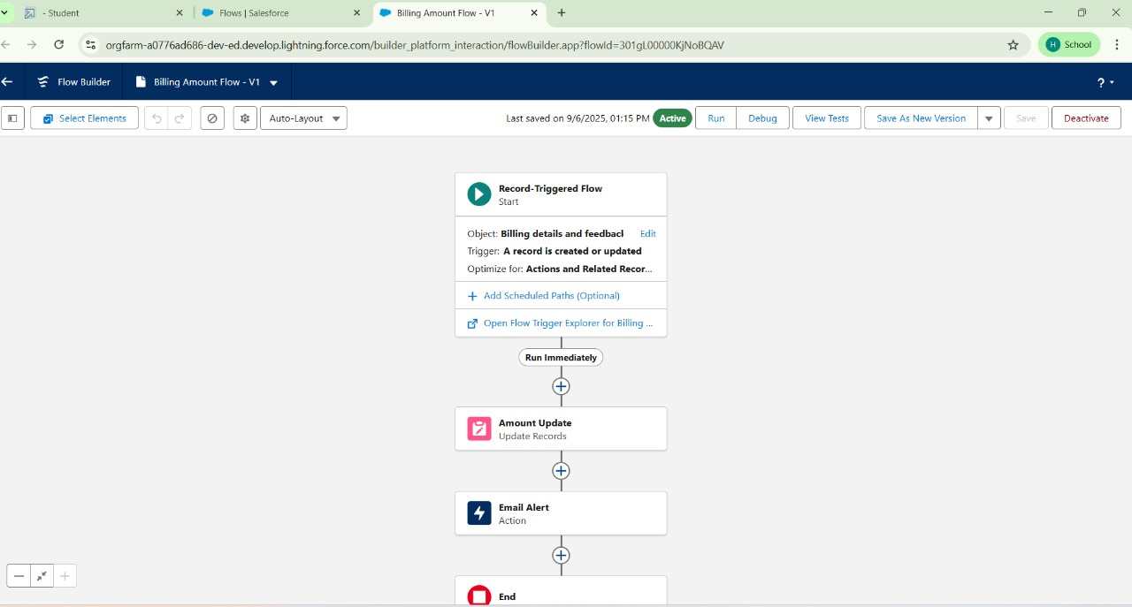

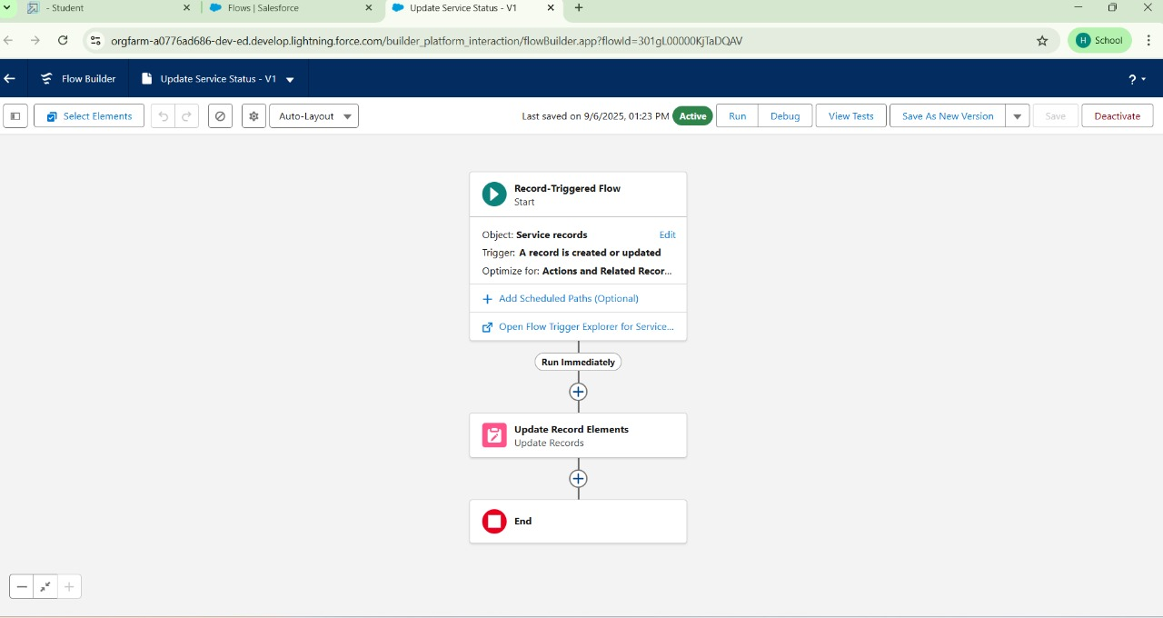

Creating and Apex Class “AmountDistributionHandler” , ” AmountDistribution”.

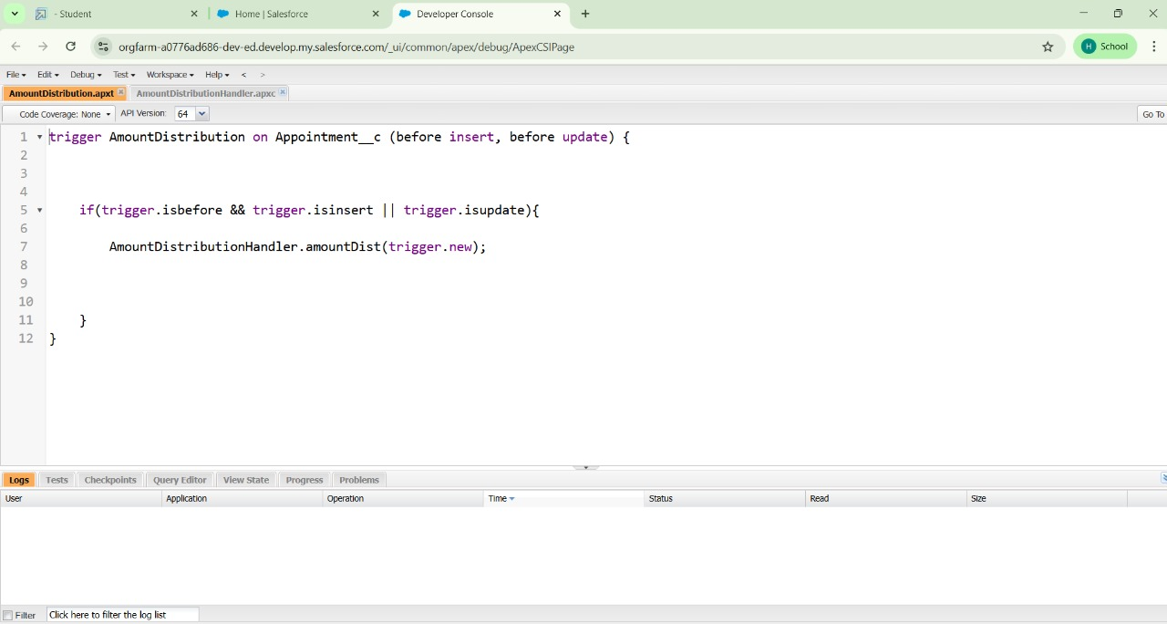

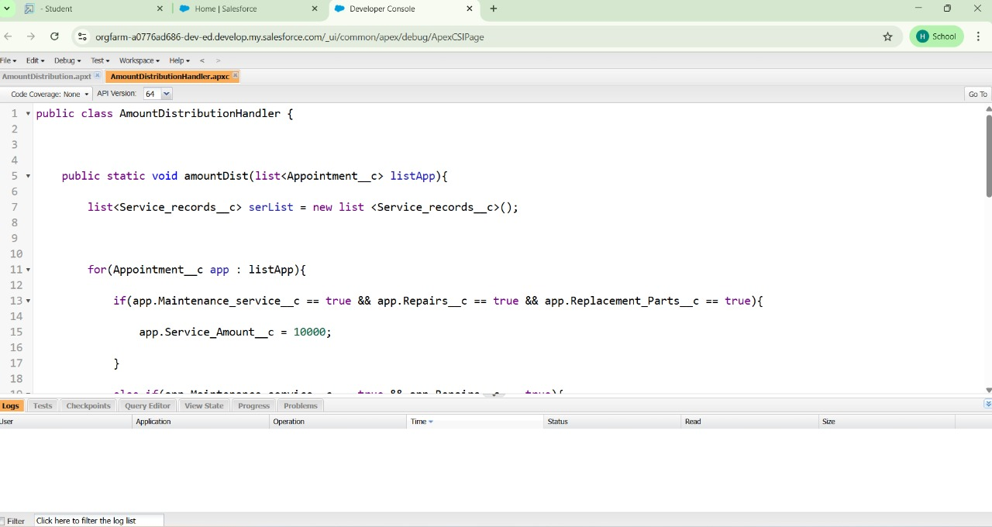

Reports

Creating a Report Folder

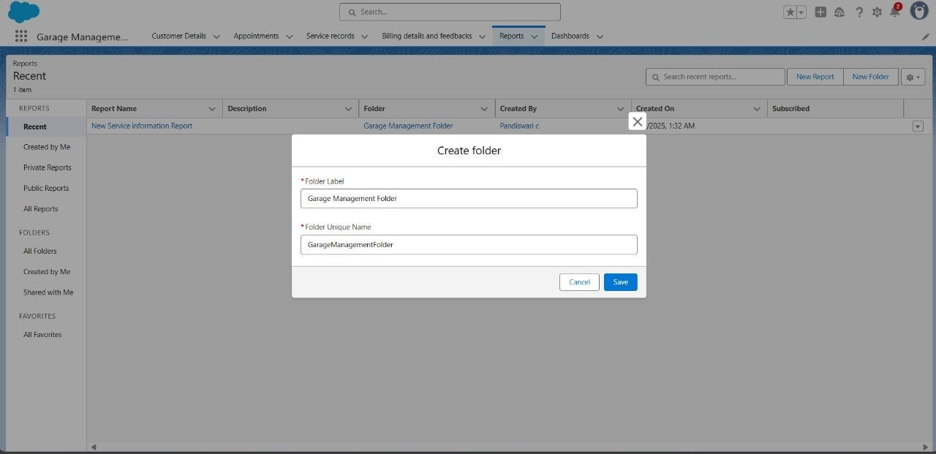

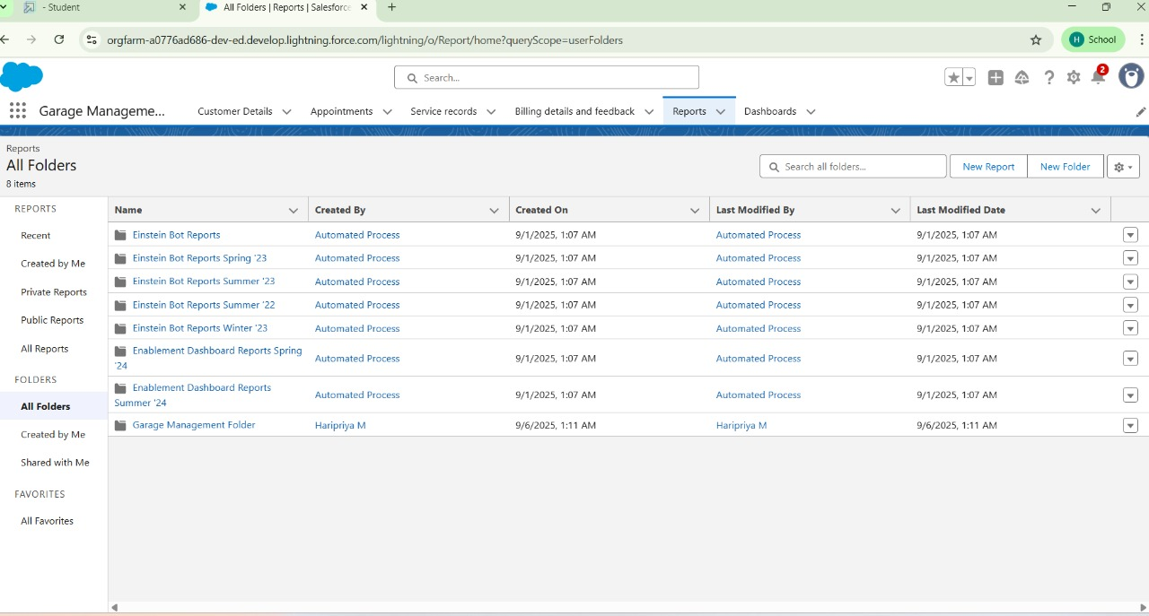

Sharing a Report Folder

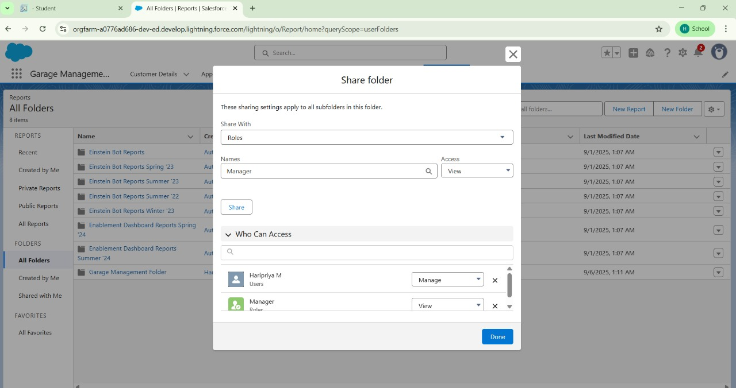

Creating Report Type

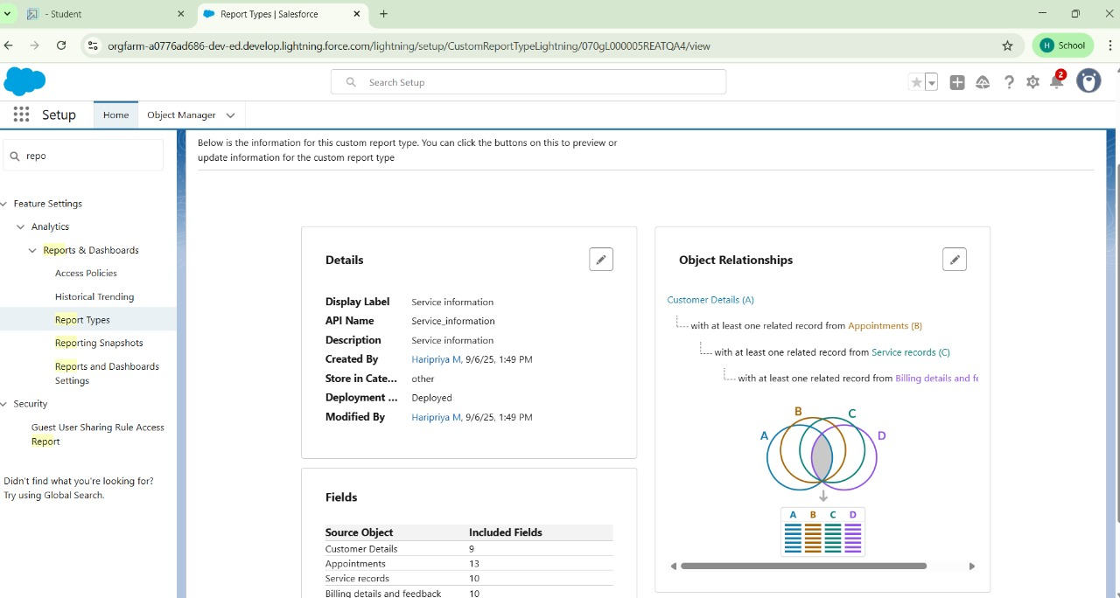

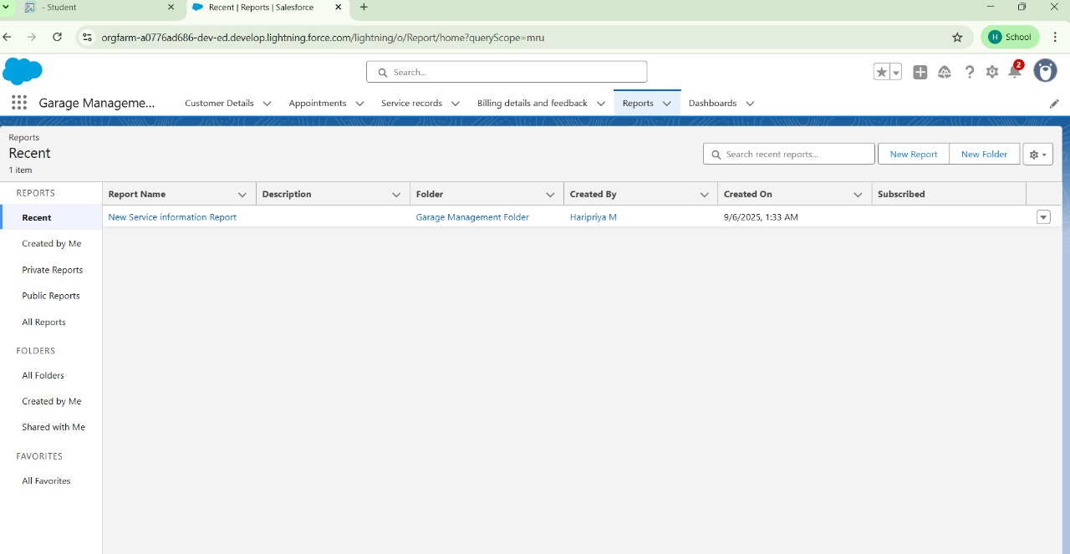

Dashboards

Creating Dashboard Folder

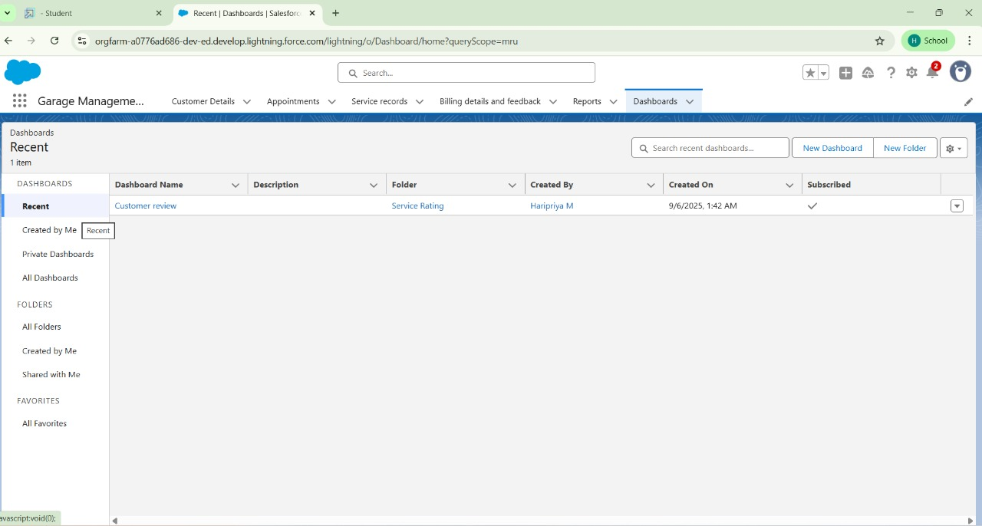

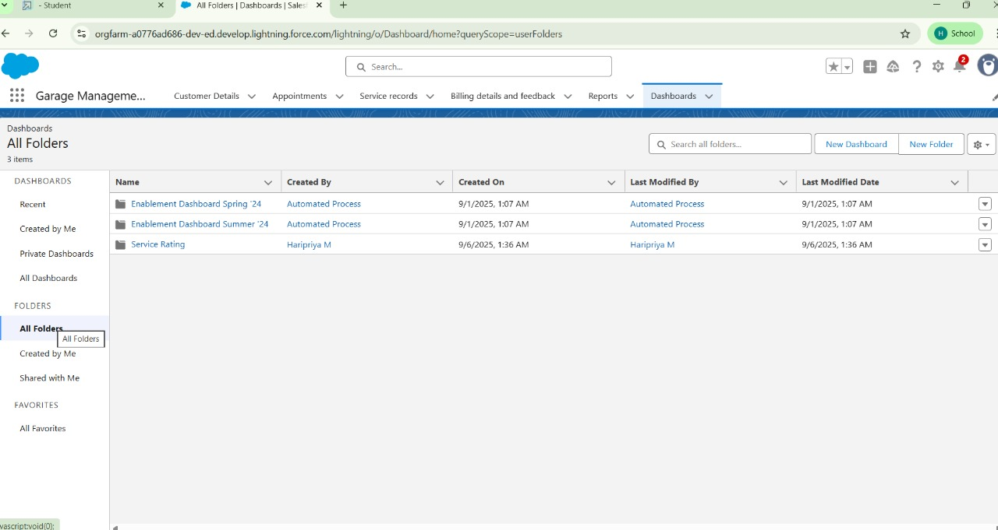

User adaption

Creating Records

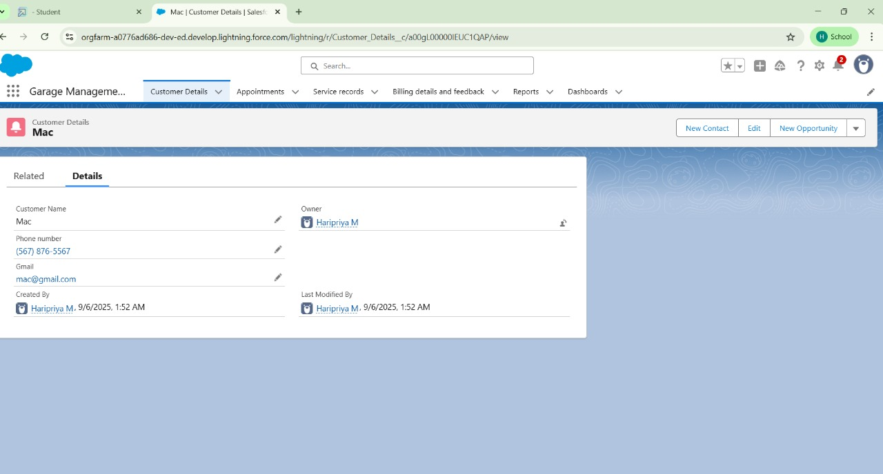

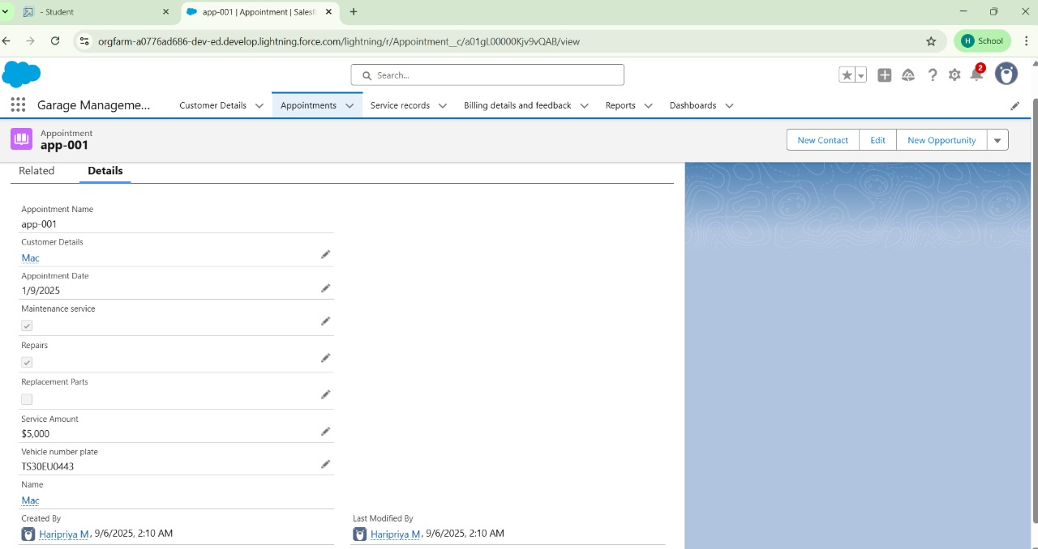

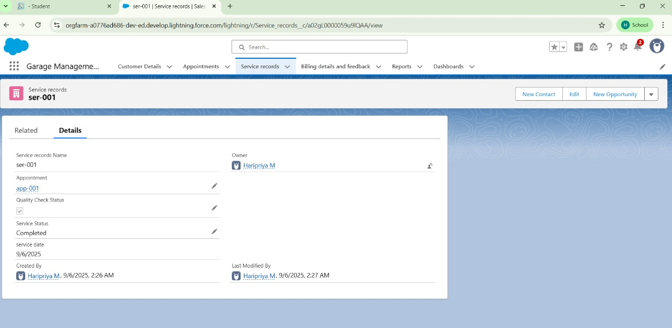

ADVANTAGES AND DISADVANTAGES **Advantages:**

* Automates garage operations, saving time
* Keeps customer and vehicle records organized
* Improves service tracking and job assignment
* Generates quick and accurate bills
* Helps manage spare parts inventory efficiently
* Provides reports for better decision-making. **Disadvantages:**
* Initial setup cost may be high
* Requires basic computer knowledge to operate
* System failure or bugs can interrupt work
* Data security is needed to protect customer information
* Regular updates and maintenance are required

CONCLUSION

The Garage Management System is a useful tool that helps automate and simplify the daily operations of a vehicle service center. It improves efficiency, reduces manual work, and ensures accurate tracking of services, inventory, and billing. Despite some initial setup and training needs, it offers long-term benefits in managing the garage smoothly and professionally.

APPENDIX

Source Code 1 :

public class AmountDistributionHandler {

public static void

amountDist(list<Appointment__c> listApp){ list<Service_records__c> serList = new list <Service_records__c>();

for(Appointment__c app : listApp){ if(app.Maintenance_service__c == true &&

app.Repairs__c == true && app.Replacement_Parts__c == true){ app.Service_Amount__c = 10000;

}

else if(app.Maintenance_service__c == true

&& app.Repairs__c == true){ app.Service_Amount__c = 5000;

}

else if(app.Maintenance_service__c == true && app.Replacement_Parts__c == true){

app.Service_Amount__c = 8000;

}

else if(app.Repairs__c == true && app.Replacement_Parts__c == true){

app.Service_Amount__c = 7000;

}

else if(app.Maintenance_service__c == true){ app.Service_Amount__c = 2000;

}

else if(app.Repairs__c == true){ app.Service_Amount__c = 3000;

}

else if(app.Replacement_Parts__c == true){ app.Service_Amount__c = 5000;

}

}

}

}

Code 2:

trigger AmountDistribution on Appointment__c (before insert, before update) {

if(trigger.isbefore && trigger.isinsert || trigger.isupdate){

AmountDistributionHandler.amountDist(trigg er.new);

}

}